Group 3 - Nathan Ketterlinus, Preet Chodavadia, Legendre Cooper, Owen Segala, Kevin Yomba

COSC350-001

Yeong-Tae Song

10/23/24

Phase 2

1. Network Design:
2. Client Server Architecture: The client will be responsible for knowing the IP address of the target server, as well as requesting to connect. The server will be responsible for being reachable, as well as accepting client requests.
3. Socket Communication: We will utilize TCP for reliable, ordered delivery of messages.
4. Connection Management: all connection initiation, maintenance, and termination processes will be handled by functions in the imported java.net library
5. GUI Design:

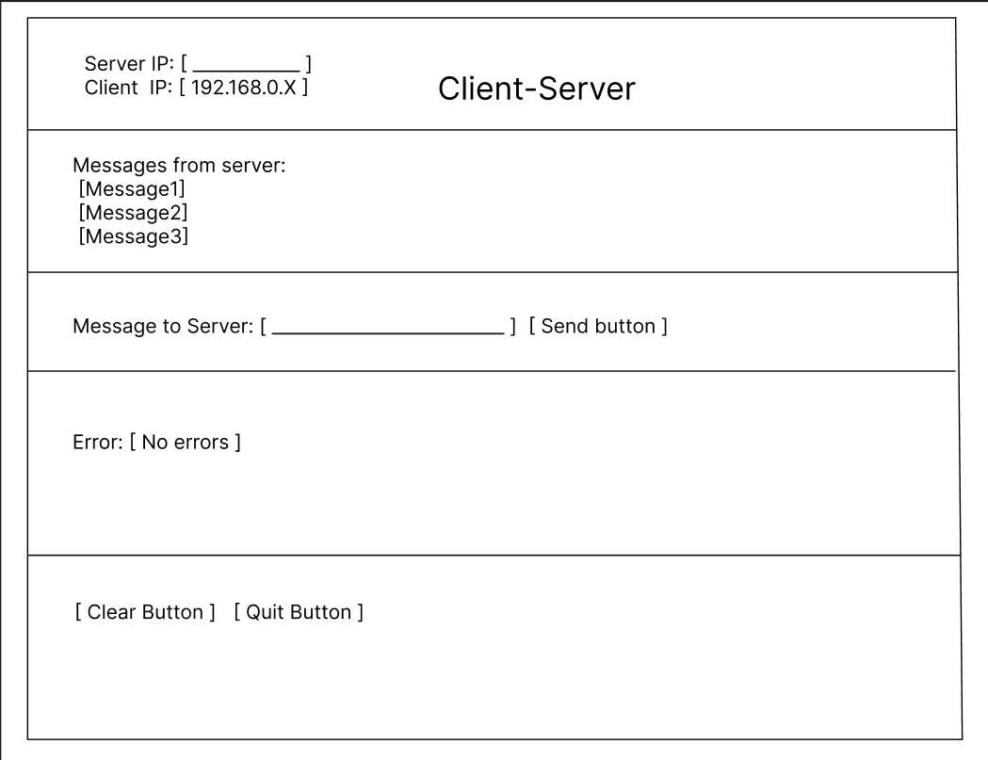

1. Event Handling: When the socket is passed to the server, it will display the client IP in the Server IP box. On Send Button(), the socket is triggered to write and send the message to the server. Incoming messages will be displayed in the chat area. The clear button will wipe the chat to be blank, and the quit button will close the socket and associated resources, and exit the program.

3.

Legendre: In charge of “Network Design”, and all related subpoints.

Owen: In charge of “GUI Design”, and all related subpoints.

Note that the other 3 members were in charge of tasks in phase 3, so they are not listed here.

Phase 3

1. Basic Socket Setup

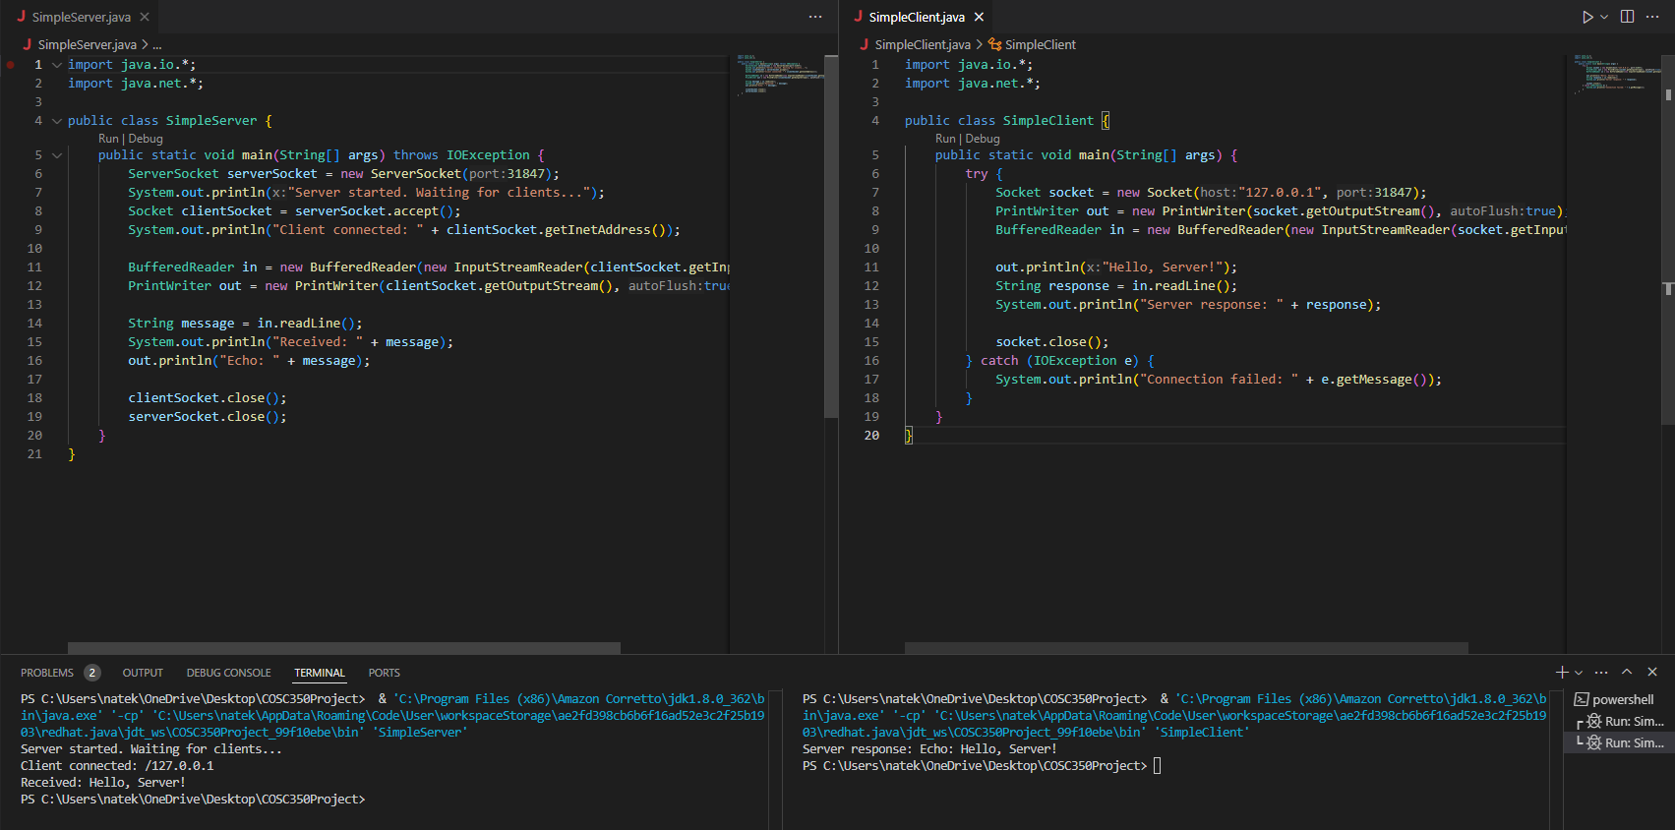

This image shows both a simple server and client program. The corresponding terminals show the output of the programs, which highlight that the socket can connect the client to the server and echo messages.

1. Basic GUI setup

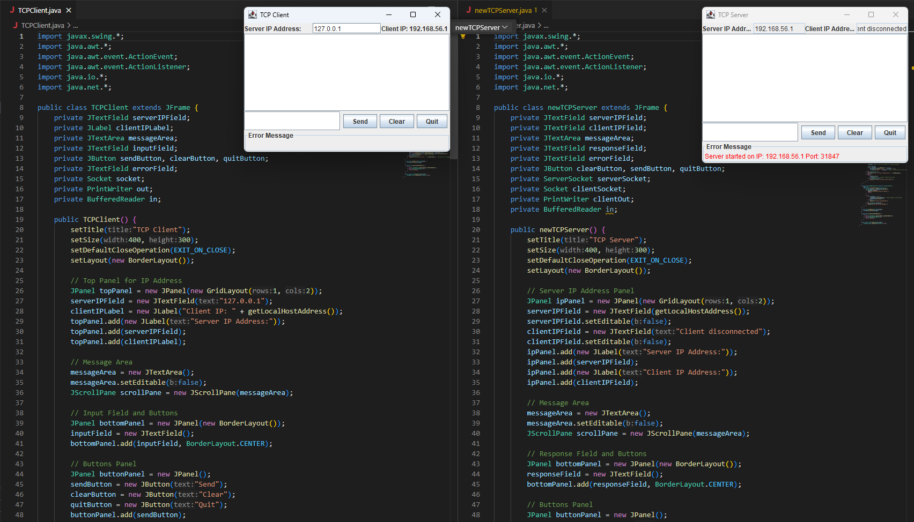The attached screenshot shows our GUI along with snippets for each of the programs. All of the backend logic is already implemented here. Code is attached to the Blackboard submission

1. Prototype Testing:

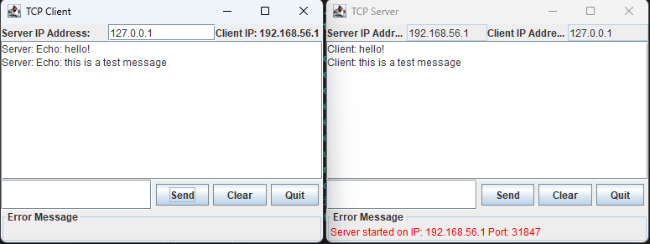

This screenshot shows the client successfully connecting to the server, sending a message to the server, and having its response echoed back to it once received. The screenshot uses the default feedback address, but the program works across devices assuming the network and related device configs (port forwarding enabled, firewall allows incoming and outgoing traffic, etc.) are set up properly.

1. Kevin: In charge of “Basic Socket Setup” and all related subpoints

Preet: In charge of “Basic GUI Setup” and all related subpoints

Nathan: In charge of “Prototype Testing and all related subpoints, as well as writing this document.